pgAdmin Overview

Wednesday, 26 April 2023

4:39 pm

# pgAdmin Overview

At the top most layer (select Servers), on the top right bar, under Dashboard, you can see some quick links and some info on getting started.

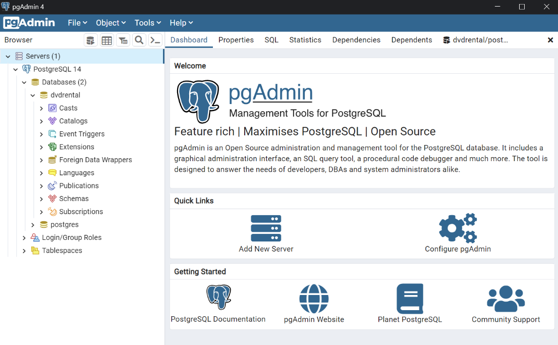

To edit preferences, go to File - Preferences.

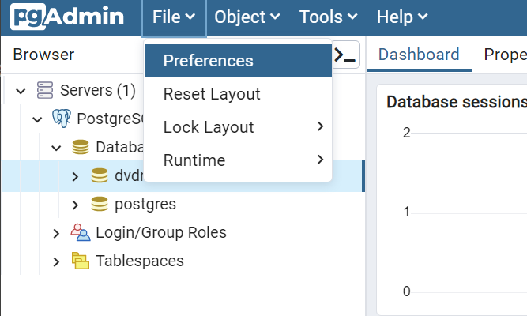

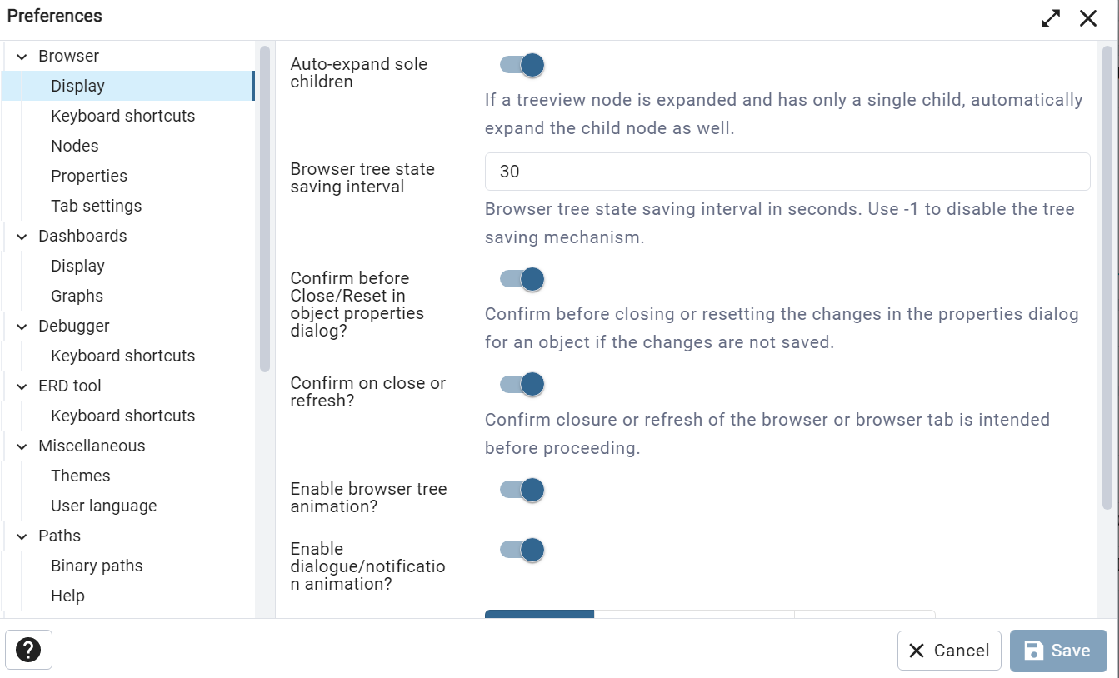

Suggestions on preferences:

* Under Miscellaneous - Themes, there is option for dark theme
* Under Query Tool - Editor, there is option to adjust font size. Default is 1 em. Can set a bigger number to scale accordingly e.g. 1.4

There are various windows, including Dashboard, Properties, SQL, Statistics, Dependencies, Dependents. For your database, you can click on them to view the respective information.

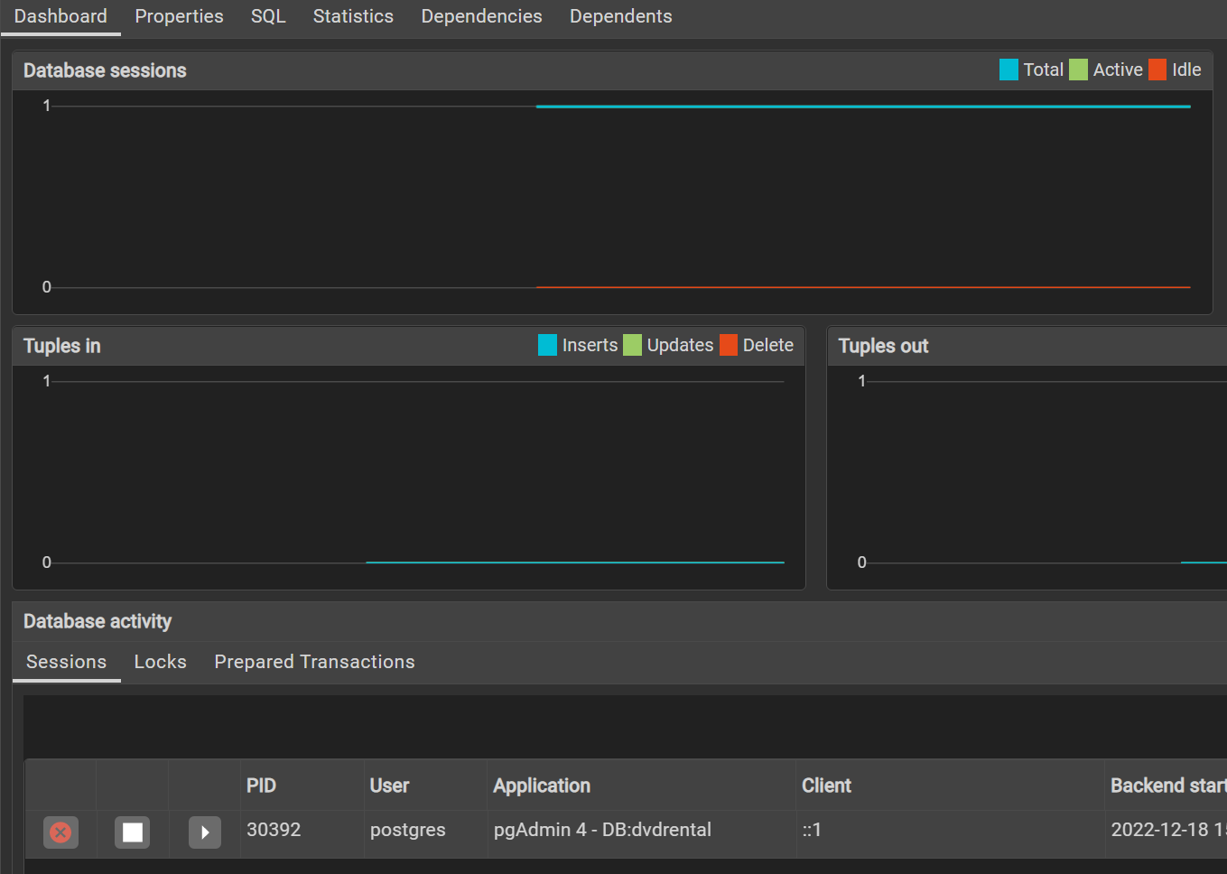

Most commonly used tool is the Query Editor. Just right click on any database to select it.

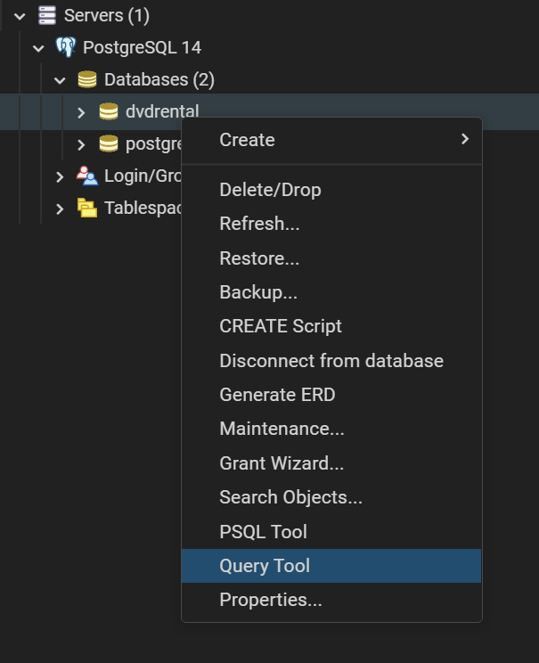

Alternatively, go to Tools, Query Tool.

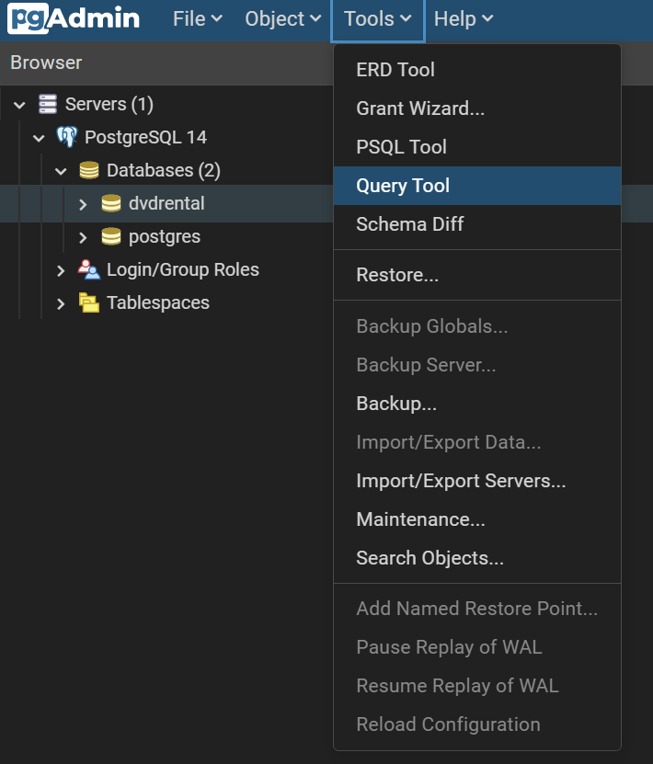

In the Query Tool, there is the Query window, which is where code is entered and run.

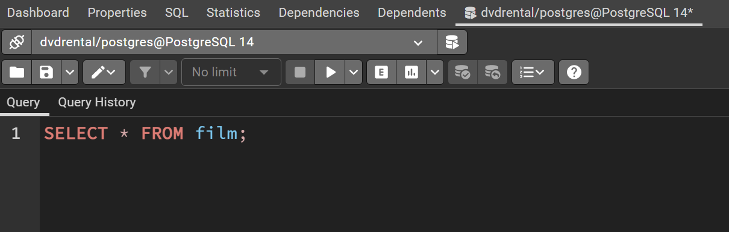

There is also the Query History window, which shows past query ran.

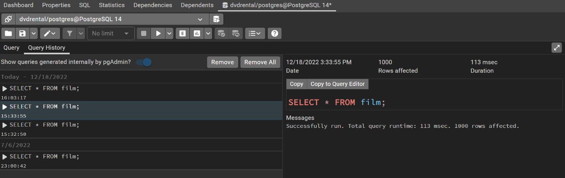

At the bottom, there is the Data output window, which displays the query results output.

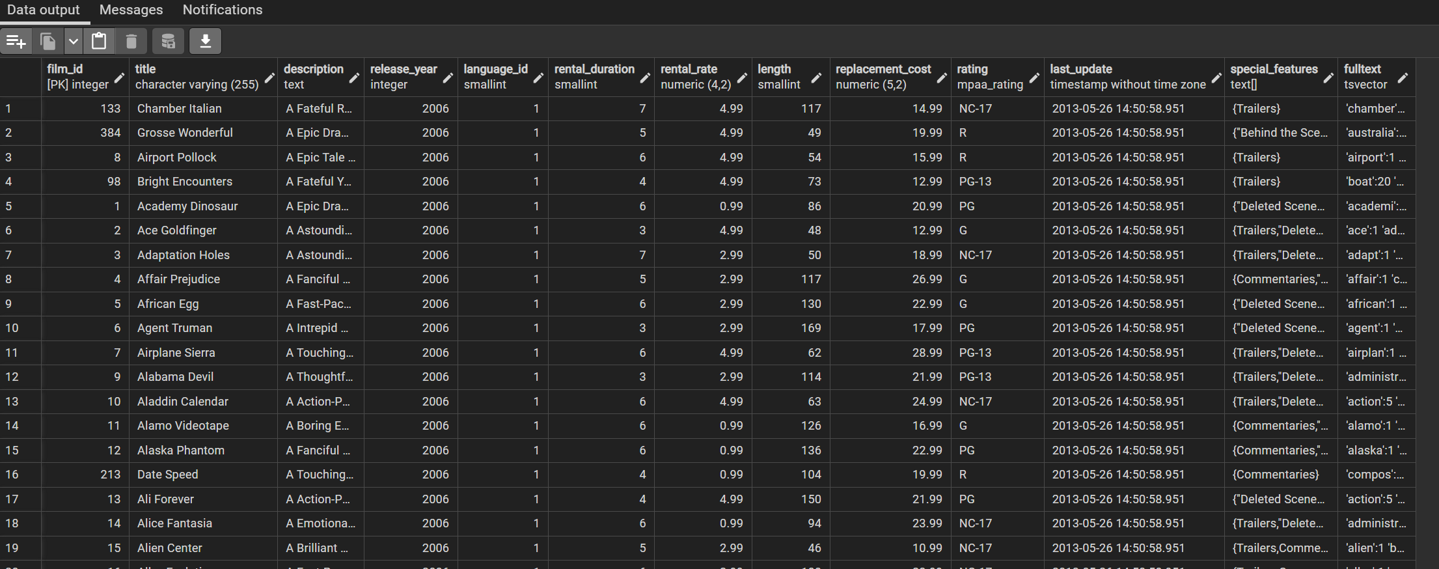

There is also the Explain window, which provides some explanation.

There is also the Messages window, which shows some message on the success / failure of the query, and how fast the query took.

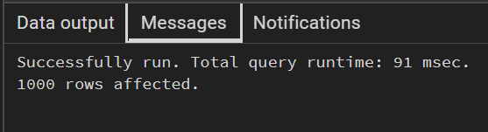

There is also the Notifications window, which shows notifications if any.

Under Data output, can click the Download button to download the output as CSV file.

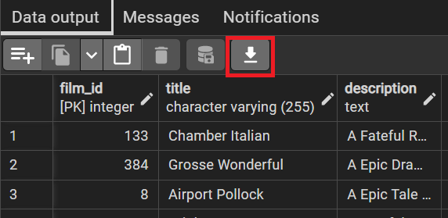

You can drag it out and back as a separate tab.

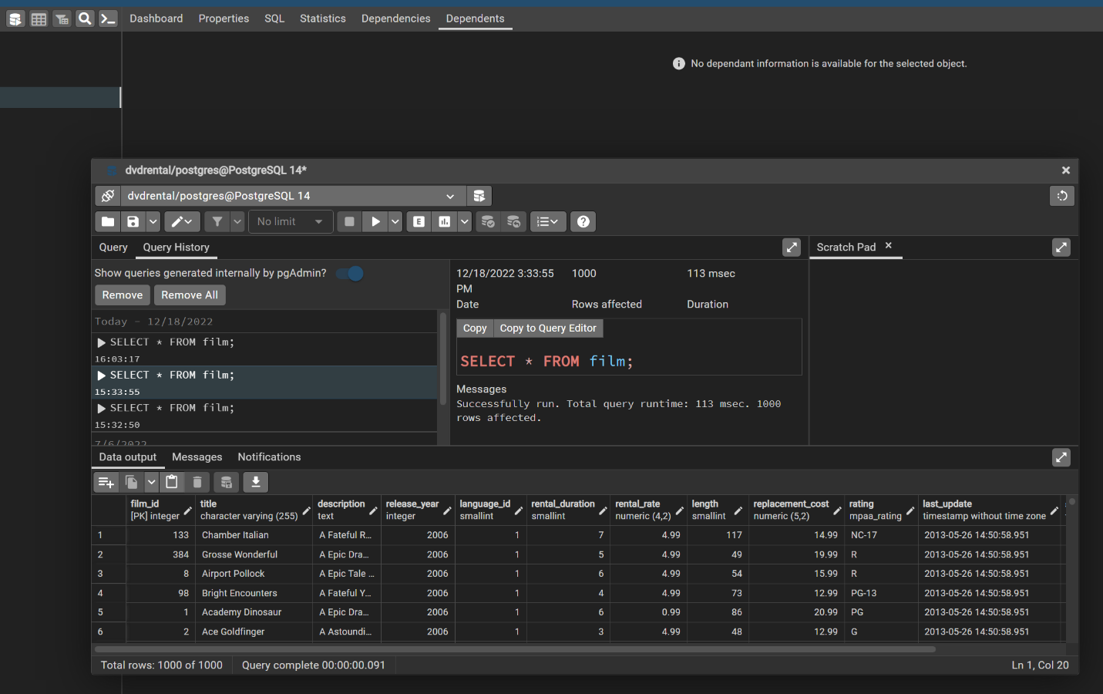

To check which tables are available, in PgAdmin, under the database, open up the schemas, public, tables.

